**Assignment 3.2**

* Creating a file with the name max-temp.txt in the local file system.

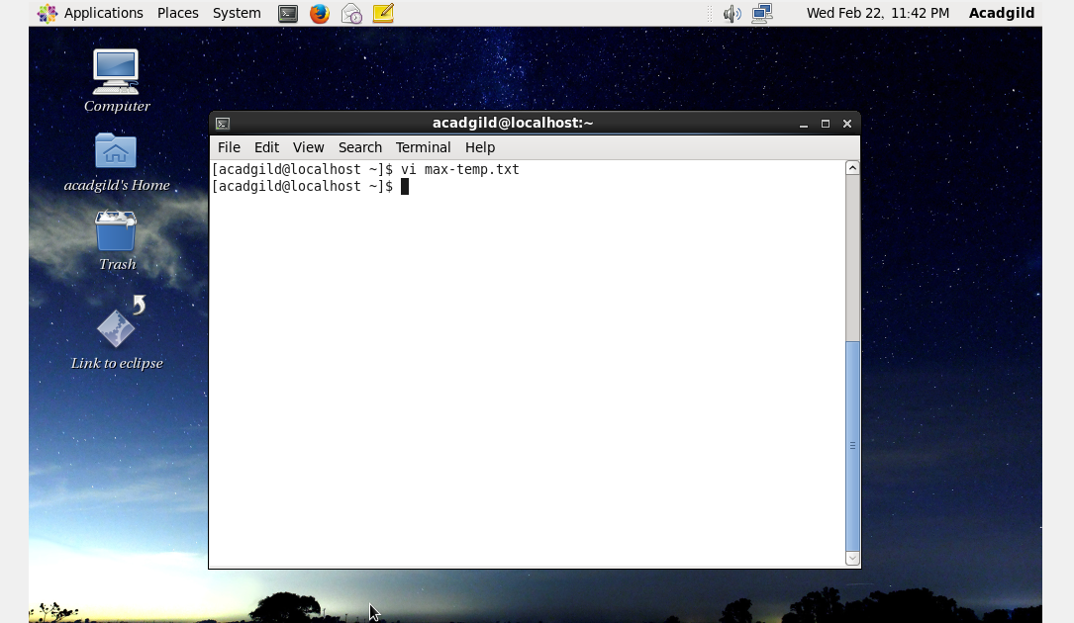

Records inside the file…

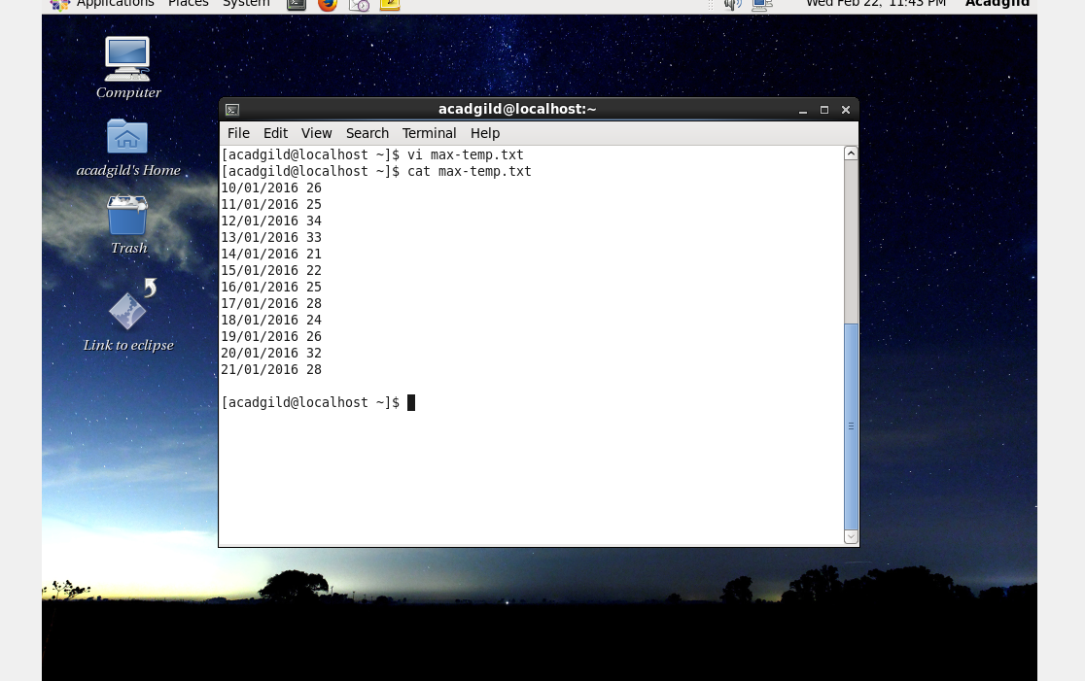

* Copying the max-temp.txt file from the local file system to HDFS in the /user/acadgild/Hadoop path.

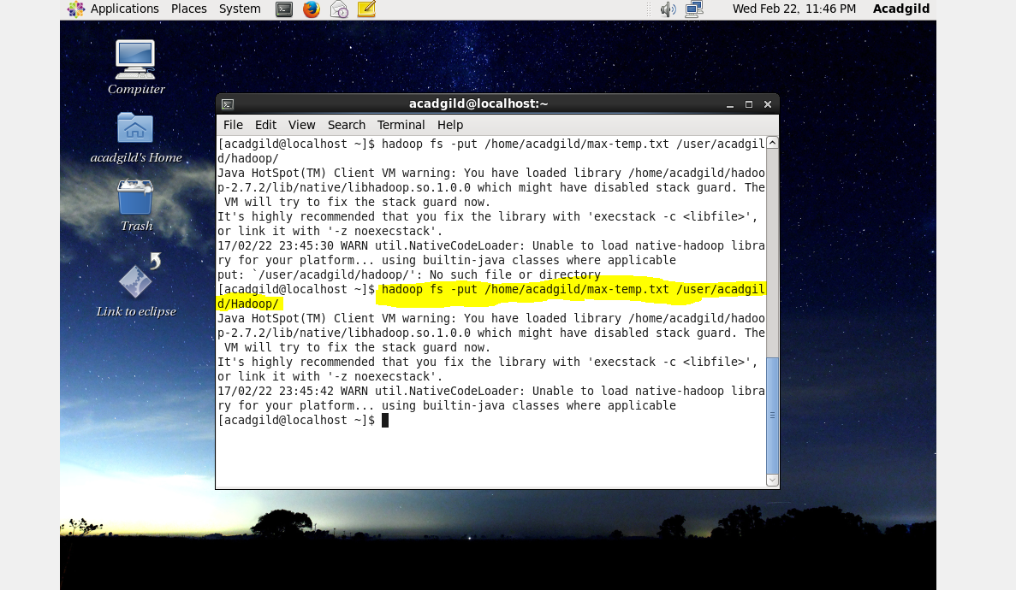

* Checking the list in HDFS Hadoop directory.

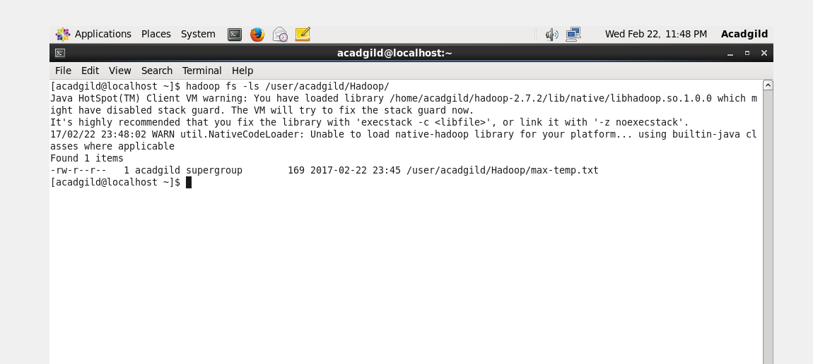

* Viewing the records in the file using cat command in HDFS Hadoop directory.

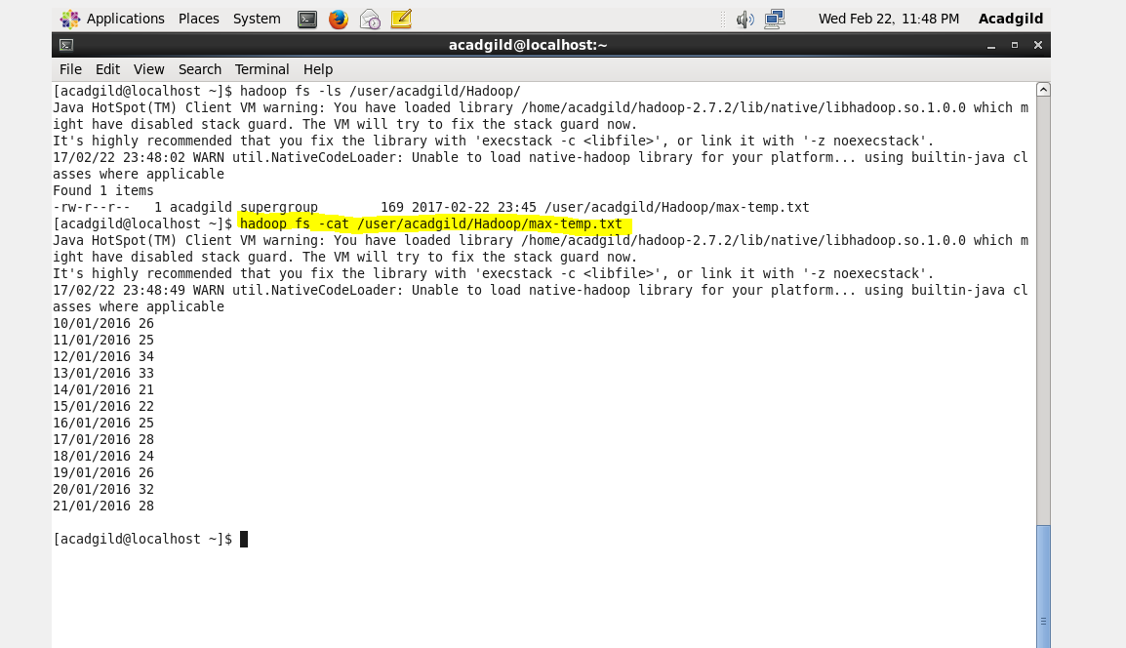

* Checking the permissions of the file…

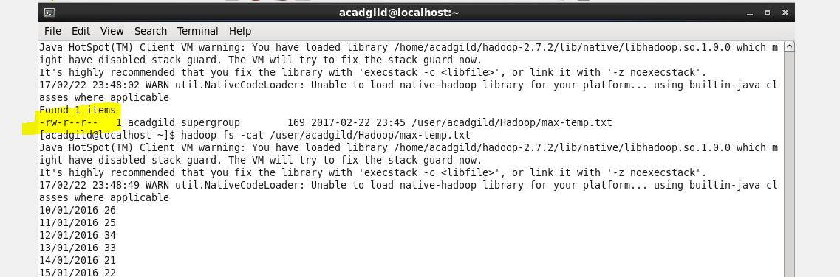

* Changing the permissions of the file such that only the owner and the group members have the r-w-x permissions and others have only read the permission.

